**Project Development phase**

**Project Development delivery of sprint 2**

|  |  |
| --- | --- |
| Team ID | PNT2022TMID50823 |
| Project name | Smart crop protection system for agriculture |

**Architecture:**

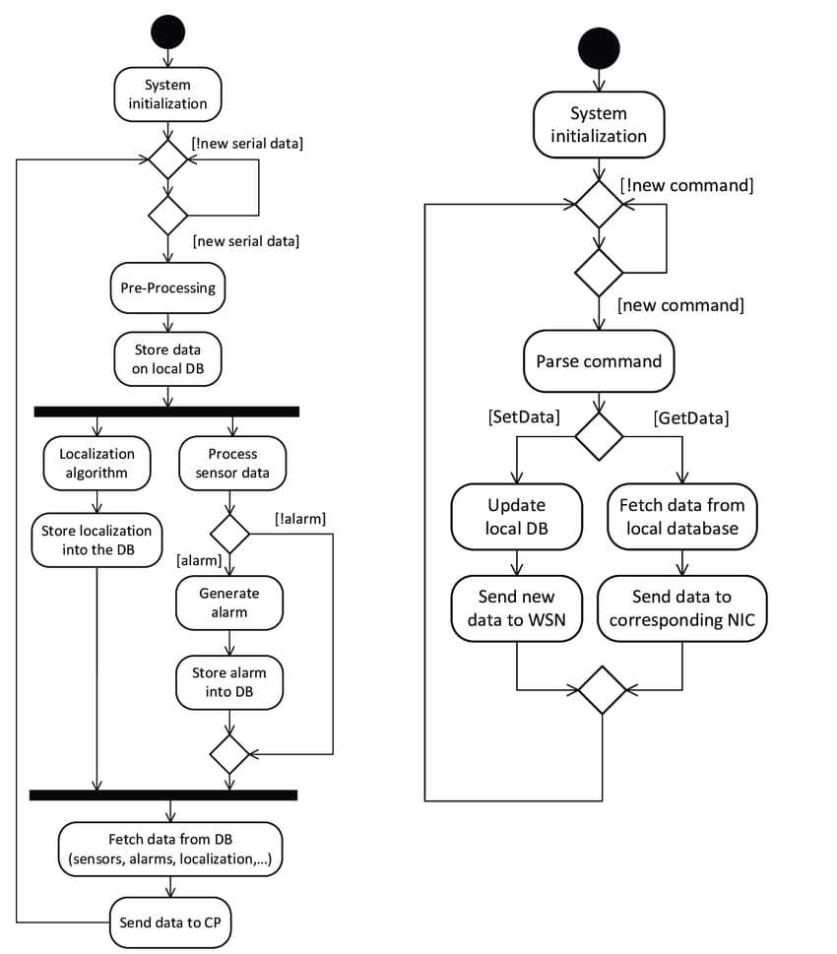

**Program/coding:**

